**Operating System Lab**

**Lab Report : 02**



**Spring 2019**

**Operating System**

Submitted By : **Naveed Ahmad**

Registration No : **17PWCSE1507**

Class Section: **B**

“On my honor, as student of University of Engineering and Technology, I have neither given nor received unauthorized assistance on this academic work.”

Submitted to:

**Dr. Tariq Kamal**

**Department of Computer Systems Engineering**

**University of Engineering and Technology, Peshawar**

**Lab Report : 02**

**Basic Shell Scripting**

**Objective:**

To know and get Familiar with Shell Scripting in Ubuntu.

## Lab Tasks

**Task : 01**

Write a Bash Script that counts the numbers of files int the current working Directory ?

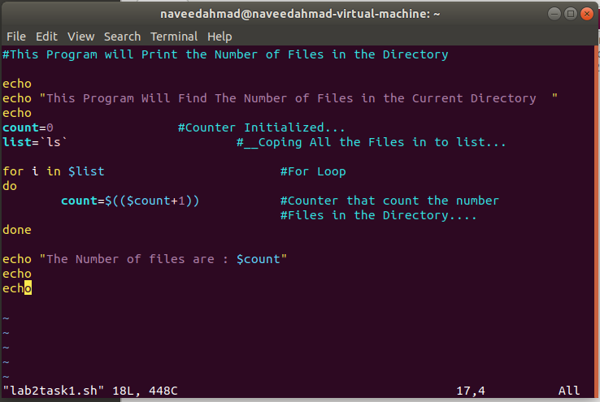**Shell Script :**

**Output :**

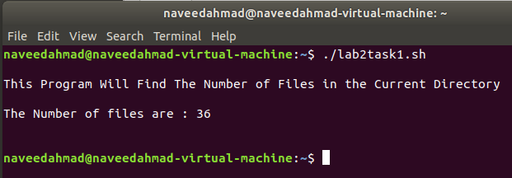

**Task : 02**

Write a Bash Script that determines the Factorial of the number pass as a Command line argument ?

**Shell Script :**

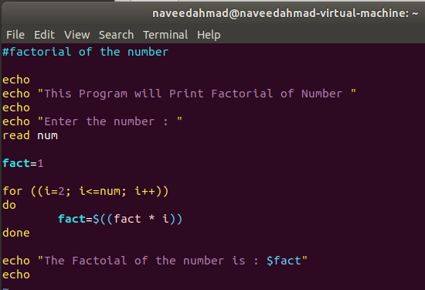

**Output :**

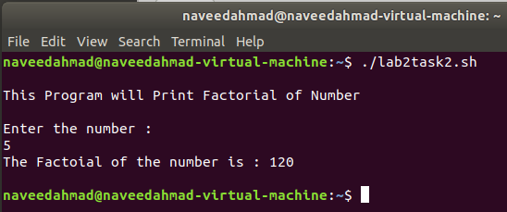

**Task : 03**

Write a Bash Script that when Executed produces a Welcome massage similar to this .

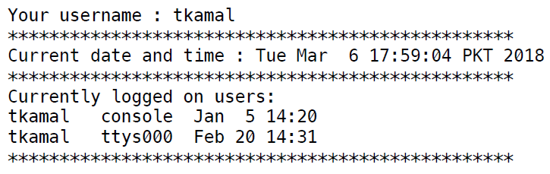

**Shell Script :**

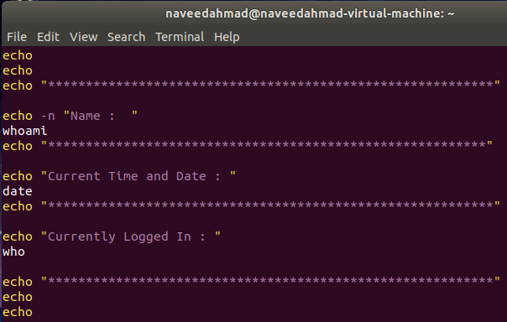

**Output :**

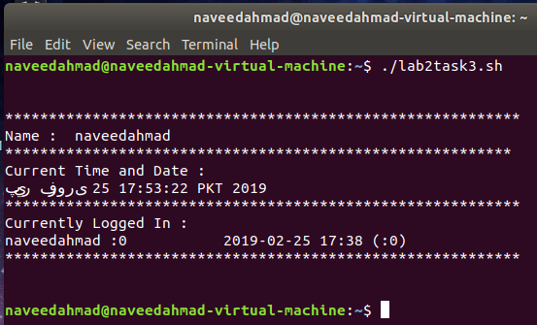

**Task : 04**

Write a Bash Script that deletes a file passed as argument. The program gives the user a Warning about deletion. If the user say “ Y ” , the file will be deleted. Other wise it’s not.

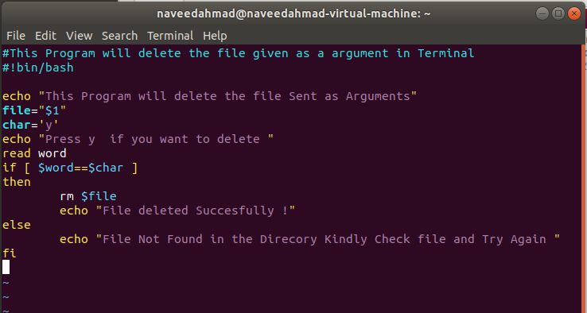**Shell Script :**

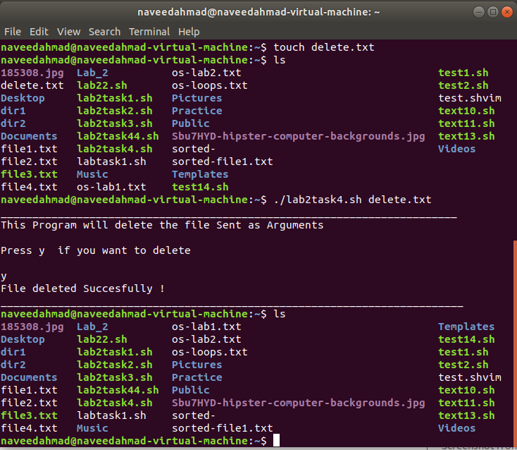**Output :**